PSHE / RSE: Statement of Intent, Implementation and Impact:
Curriculum Intent for PSHE / RSE: What we are trying to achieve with our PSHE / RSE curriculum.
- Personal Social Health Education (PSHE) including Relationships Sex Education (RSE) is at the heart of our school values and ethos and runs throughout all that we do.
- Our PSHE/ RSE curriculum aims to enable our children to become healthy, safe, independent, responsible members of society who demonstrate respect and tolerance and who are prepared to face and manage the challenges and opportunities of an ever-changing modern Britain.

We will:
- help pupils to aspire to be the best they can be, to have dreams for their future and know what is required to reach them.
- provide opportunities for our pupils to learn about rights and responsibilities and appreciate what it means to be a valuable member of an ever-changing diverse society. We will help them to understand, consider and discuss many of the moral, social and cultural issues that are part of growing up in Modern Britain.
- deepen our pupils’ understanding of the fundamental British values of democracy, individual liberty, the rule of law and mutual respect and tolerance
- develop their sense of self-worth by playing a positive role in contributing to school life and the wider community.
- stimulate, challenge and nurture children’s spiritual, moral, social and cultural curiosity.
- help pupils to understand the importance of their physical and mental health, understand emotions and feelings and have strategies to help them become resilient and confident so they are ready for the transition to Secondary school.
- help pupils to have a good understanding of themselves, to have empathy, an ability to work with others and to form and maintain positive relationships treating everyone equally with tolerance and respect.
- teach our pupils’ age-appropriate understanding of healthy relationships through appropriate relationship and sex education.
- teach our pupils about personal safety (online and off-line) and we will ensure pupils know where and how to get help if needed.
- encourage all of our pupils to be the best version of themselves that they can be!

Implementation: How do we deliver the PSHE / RSE curriculum?
- Personal Social Health Education (PSHE) including Relationships Sex Education (RSE) is at the heart of our school ethos and runs throughout all that we do.
- Pupils are taught regularly timetabled PSHE / RSE lessons by a member of staff, be that class teacher or TP with whom the pupils are familiar.
- Staff follow a tailor-made whole school scheme (SCARF) to plan their lessons.
The Curriculum is split into 6 themes and is taught as a spiral curriculum so topics are re-visited in more depth to match the maturity of the pupils.
-Me and My Relationships
-Valuing Difference
-Keeping Safe
-Rights and Respects
-Being My Best
-Growing and Changing
- Units begin with a pre-assessment task to elicit the current knowledge and understanding of the children in the class. The children will then complete the activity again as a post assessment to see how their outlook and understanding on a particular topic has changed throughout the unit’s learning.
- Lessons are adapted to meet the needs of each individual class / pupils and to deal with issues as they arise.
- Lessons are delivered in a way that ensures pupils feel safe and encourages participation by using a variety of teaching approaches with opportunities to develop critical thinking and relationship skills.

- RSE is not taught as a specific unit. The relevant statutory objectives are taught throughout the entire PSHE curriculum.

- Assemblies, themed days, visits and visitors are used to support the teaching and are not used in place of it.
- We work in partnership with parents informing them about what their children are learning and when required, providing guidance towards resources that can be used at home.
  - Lessons and school ethos;
-promote safe, equal, caring and enjoyable relationships and we discuss real-life issues appropriate to the age and stage of pupils, including friendships, families, consent, relationship abuse, sexual exploitation and safe relationships online
- give a positive view of human sexuality, with honest and medically accurate information, so that pupils can learn about their bodies and sexual and reproductive health in ways that are appropriate to their age and maturity
-gives pupils opportunities to reflect on values and influences (such as from peers, media, faith and culture) that may shape their attitudes to relationships and sex, and nurtures respect for different views
-includes learning about how to get help and treatment from sources such as the school nurse and other health and advice services, including reliable information online
-fosters gender equality and LGBT+ (lesbian, gay, bisexual, trans) equality and challenges all forms of discrimination.
-meet the needs of all pupils with their diverse experiences - including those with special educational needs and disabilities

Impact: What difference is the curriculum making to our pupils?
  - We are proud of the PSHE / RSE work that we deliver at Brimscombe, the evidence being seen through the well-rounded, confident, tolerant and independent pupils that leave us at the end of year 6.
  - The pupils’ attitude, behaviour and demeanour around school, within lessons, at playtimes’ and out in the community demonstrates the respect, tolerance and high aspirations that our pupils have of themselves and each other.
  - Pupils leave us ready for their next step into Secondary school and are armed with skills, knowledge and understanding that they can take forward into adulthood.
  - Our pupils leave us prepared for life in an ever-changing modern Britain. They have the tools they need to succeed, keep themselves safe and thrive.

We measure impact by the triangulation of lesson observations, book looks and pupil voice, as well as this we carry our bi-termly subject leader/ teaching staff discussions – where we discuss the outcomes from monitoring, areas for development are discussed, and subsequently, targets are discussed and agreed upon as a staff. The results of this monitoring then directly feeds into the subsequent years subject action plan maintaining a constant cycle of reflection and improvement in the planning, teaching and assessment of PSHE and RSE.

SCARF sessions meeting statutory requirements.

Relationships Education

Families and people who care for me
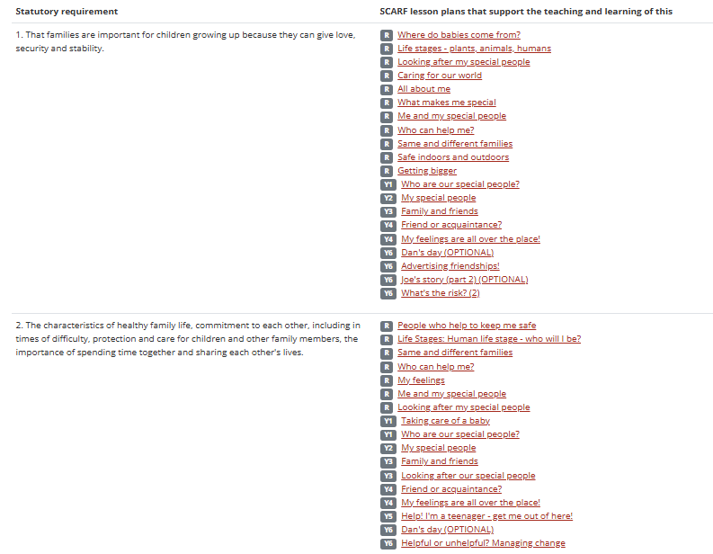
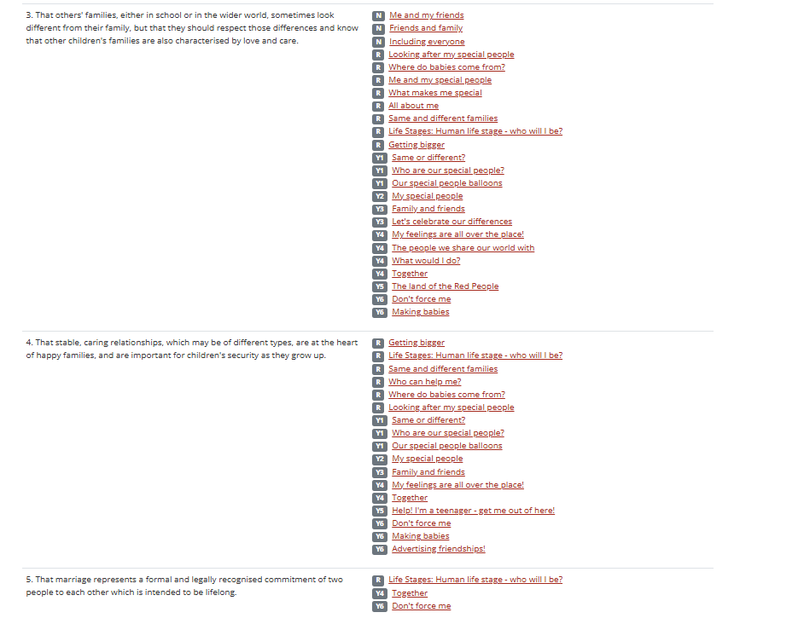
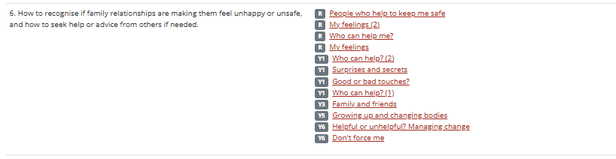
Caring friendships
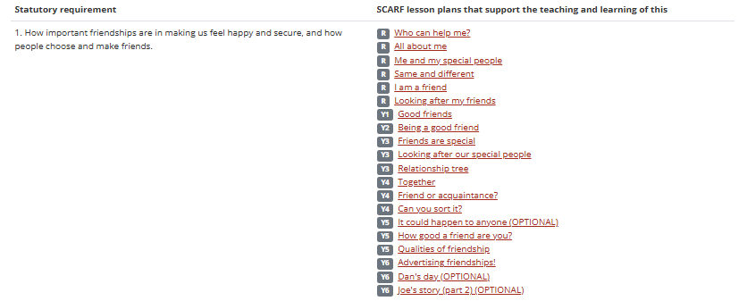
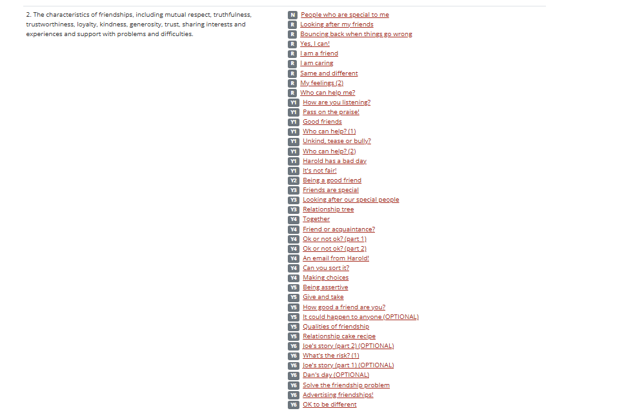
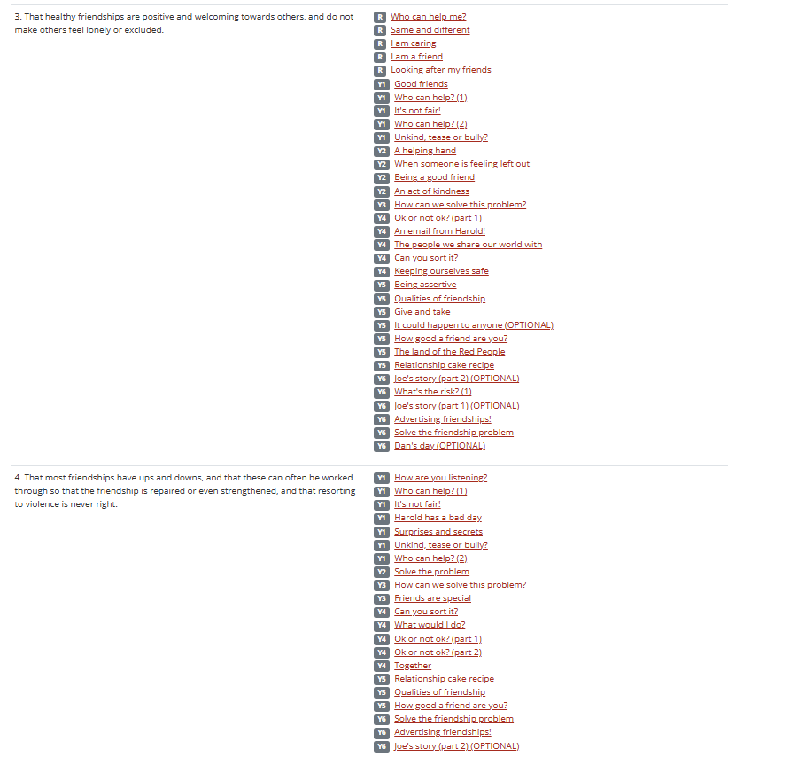
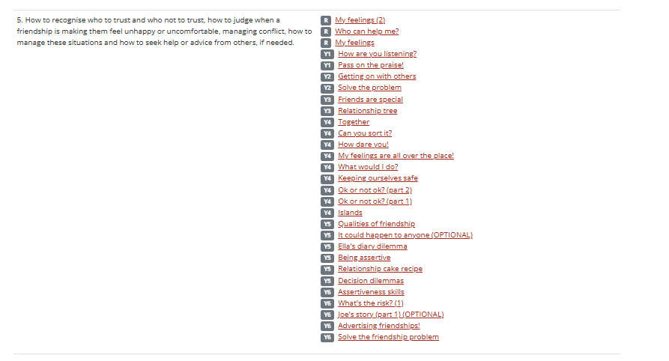

Respectful relationships
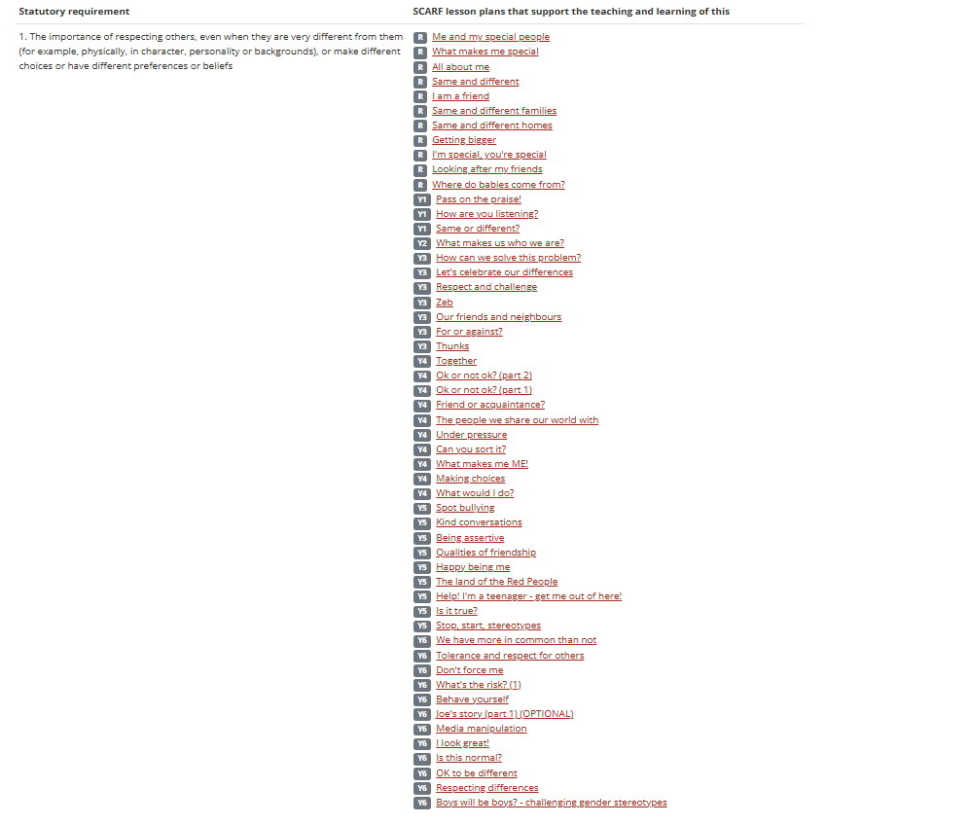
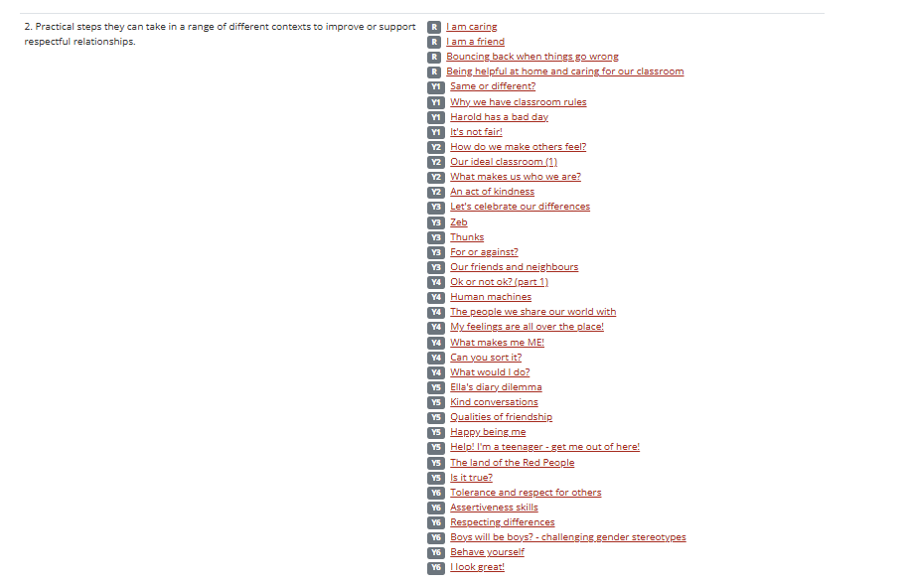
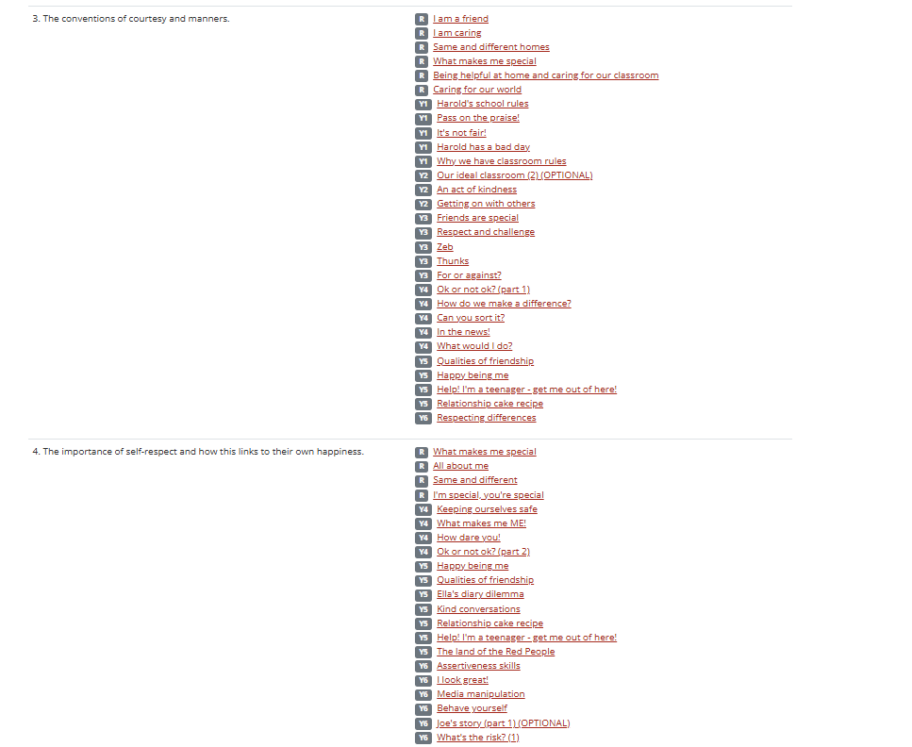
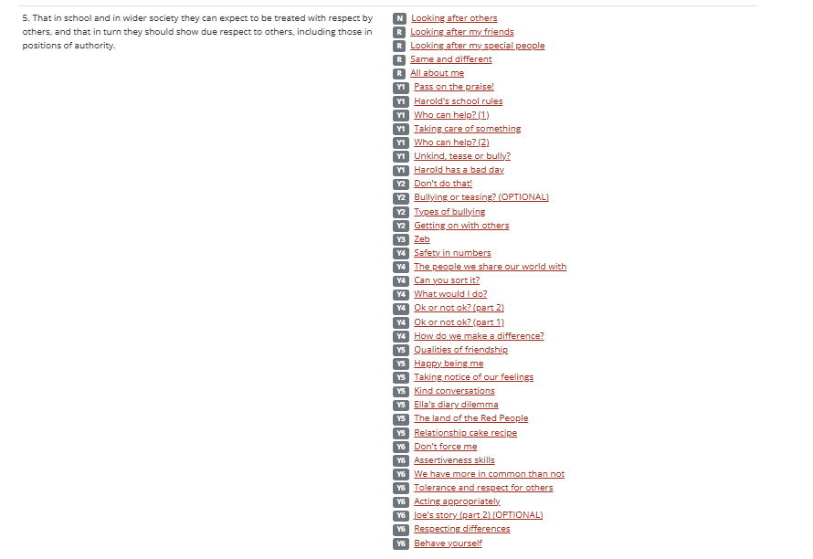
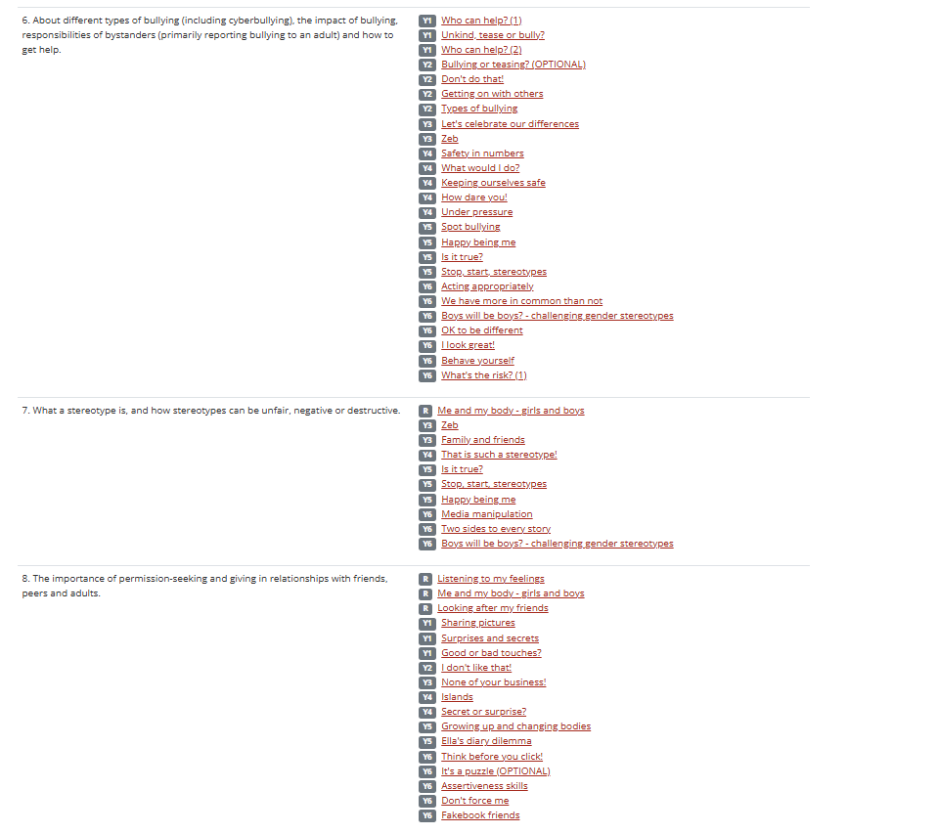

Online relationships
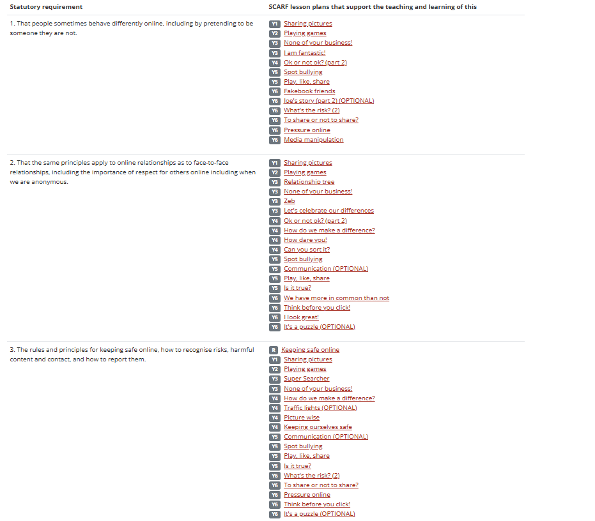
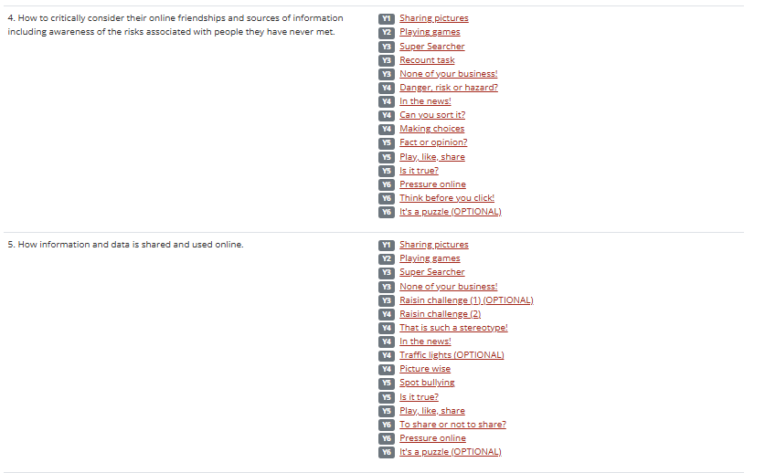

Being safe
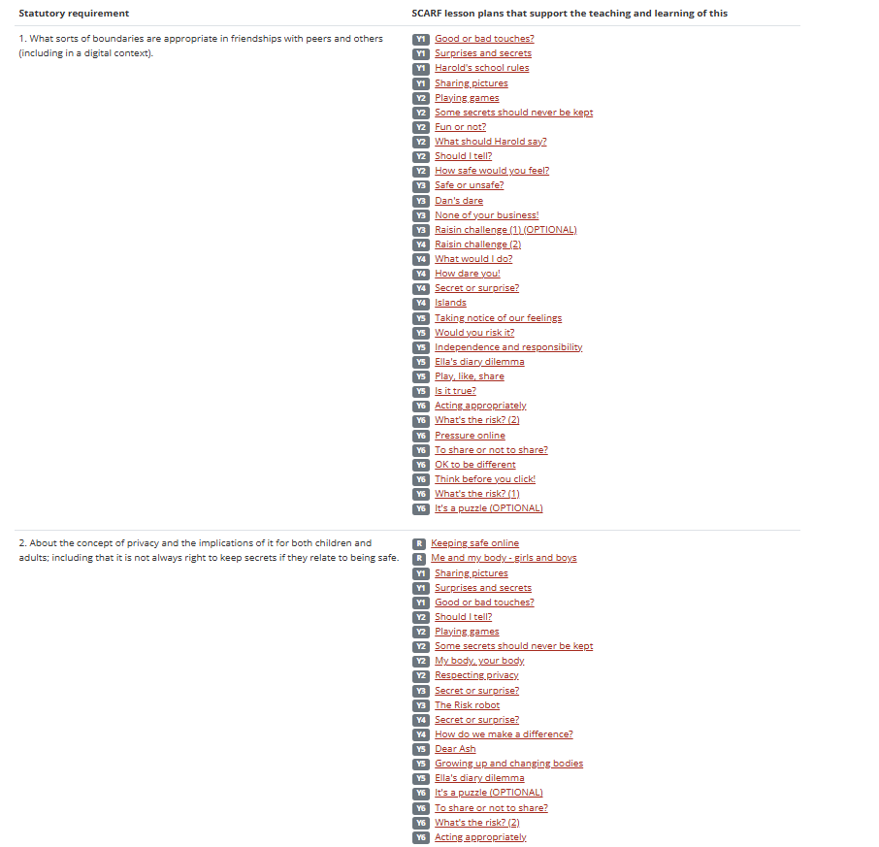
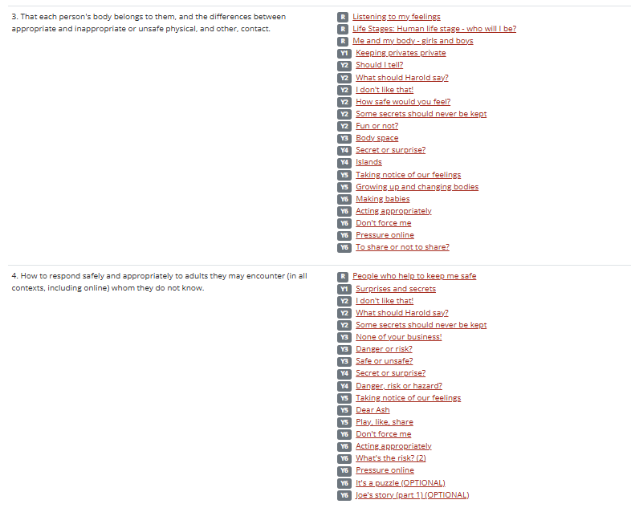
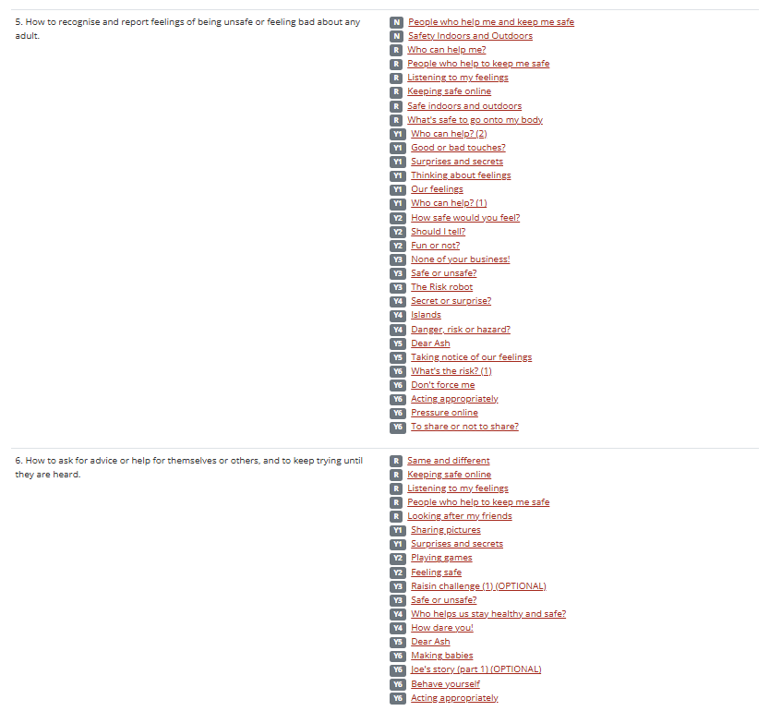
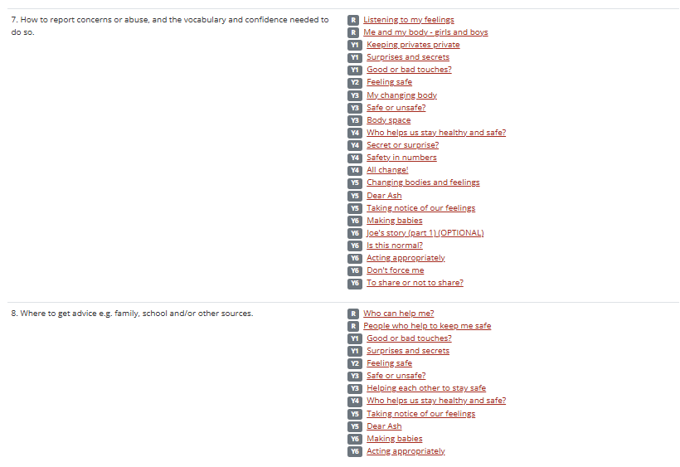

Physical Health and Mental Wellbeing (Health Education)

Mental wellbeing
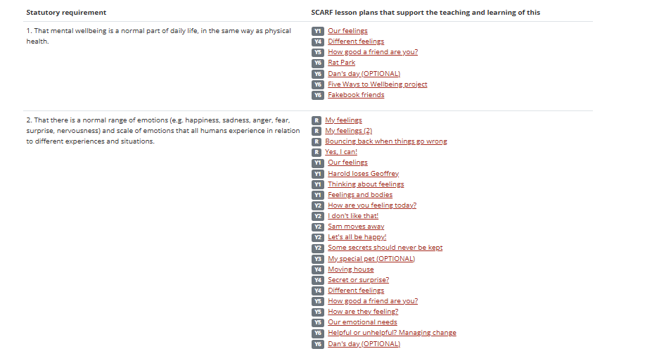
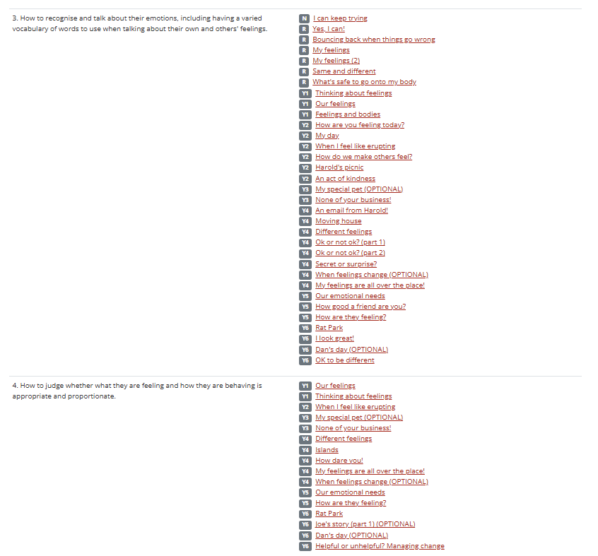
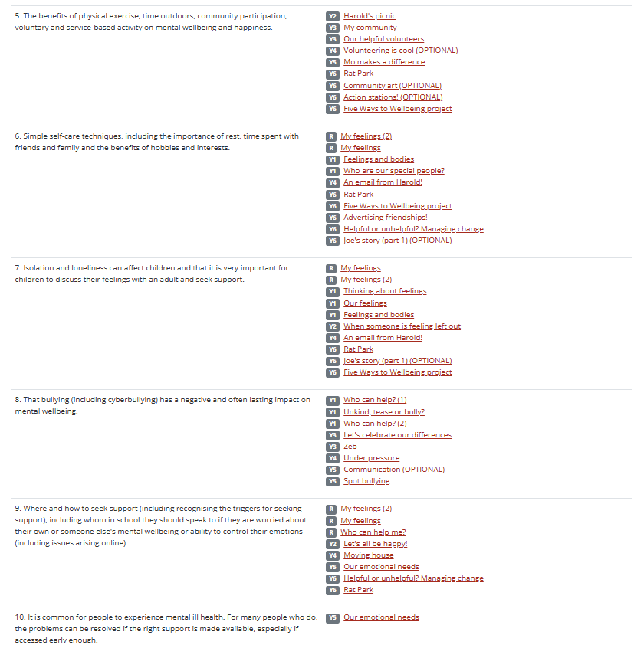

Internet safety and harms
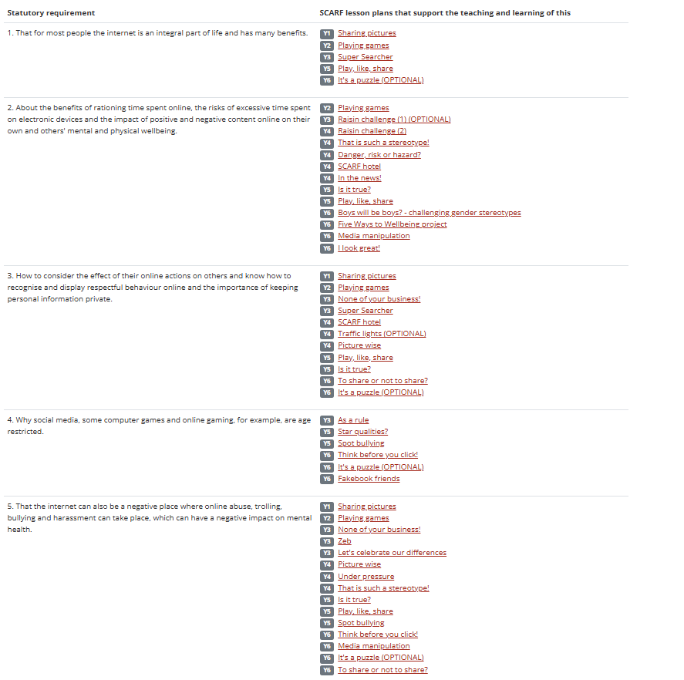
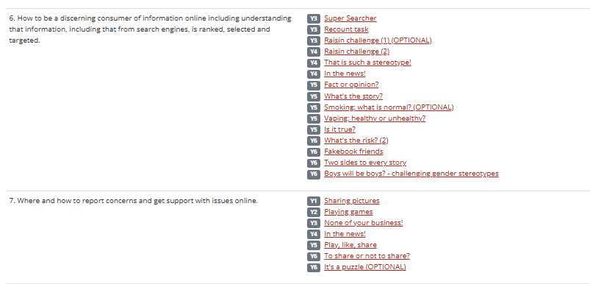

Physical health and fitness
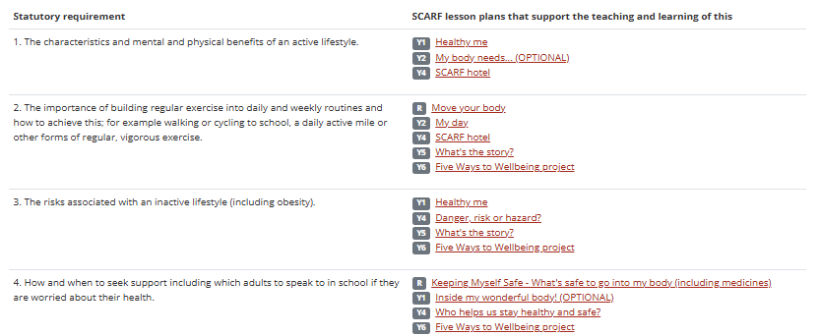

Healthy eating
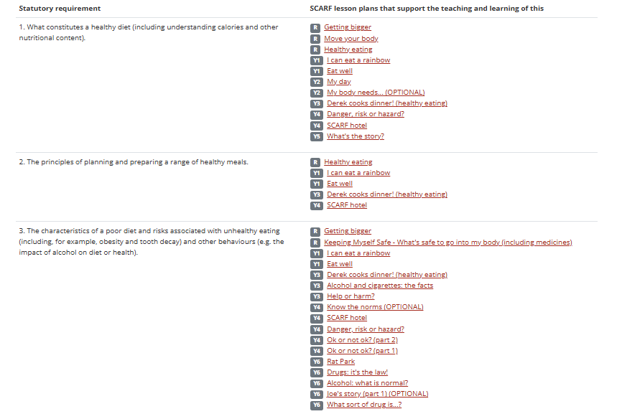

Drugs, alcohol and tobacco
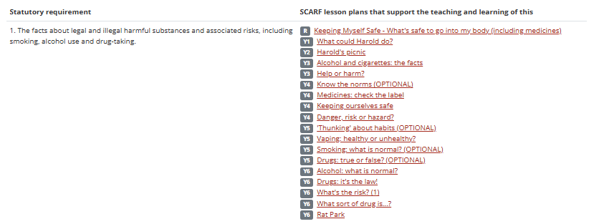

Health and prevention
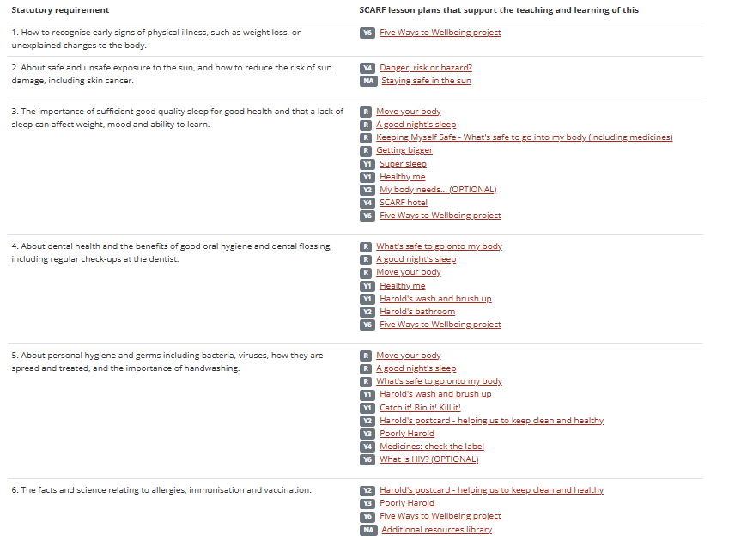

Basic first-aid
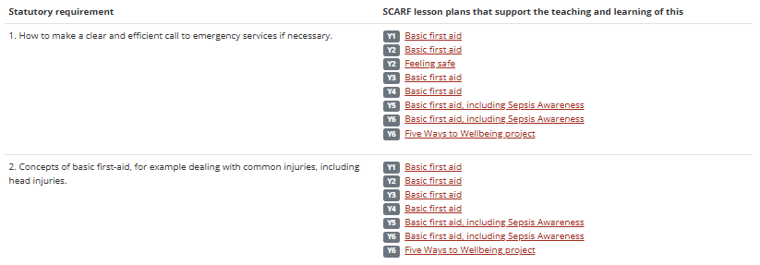

Changing adolescent body


